**Q.1 Write a program to implement “Finalize()” method**.

public class Javafinalizemethod

{

public static void main(String[] args)

{

Javafinalizemethod obj = new Javafinalizemethod();

obj = null;

System.gc();

System.out.println("end of garbage collection");

}

protected void finalize()

{

System.out.println("finalize method called");

}

}

**Output :-**

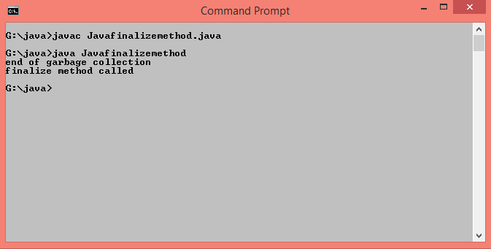

**Q.2 Write a program to define class Person and create object using**

**A.new Keyword**

**B.newInstance()**

**C.clone() method**

public class Person implements Cloneable

{

String s="Object Created by new keyword";

void show()

{

System.out.println("Object Created by newInstance()");

}

void display()

{

System.out.println("Object Created by clone() method");

}

public static void main(String args[])

{

Person p=new Person();

System.out.println(p.s);

try

{

Class cls = Class.forName("Person");

Person p1 =(Person) cls.newInstance();

p1.show();

}

catch(ClassNotFoundException e)

{

e.printStackTrace();

}

catch(InstantiationException e)

{

e.printStackTrace();

}

catch(IllegalAccessException e)

{

e.printStackTrace();

}

Person p2=new Person();

try

{

Person p3=(Person)p2.clone();

p3.display();

}

catch(CloneNotSupportedException e)

{

e.printStackTrace();

}

}

}

**Output :-**

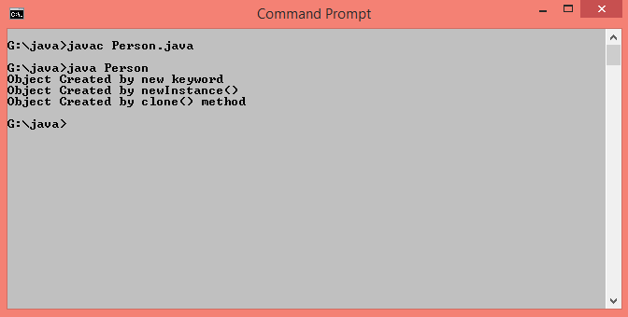

**Q.3 Write a program to implement constructor,parameterized constructor and constructor overloading.**

class Area

{

Area()

{

System.out.println("Example of Constructor Overloading");

}

Area(int r)

{

System.out.println("Area of Circle="+(3.14*r*r)+" Sq.unit");

}

Area(int l,int b)

{

System.out.println("Area of Rectangle="+(l*b)+" Sq.unit");

}

}

class ConstructorOverloading

{

public static void main(String args[])

{

Area c=new Area();

Area c1=new Area(4);

Area c2=new Area(10,8);

}

}

**Output :-**

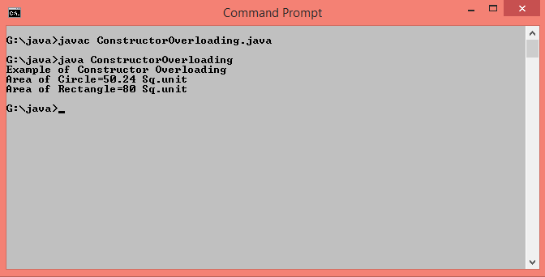

**Q.4 Write a program to design class Employee with public and private data members.**

import java.util.*;

class Employee1

{

private int id;

public String name;

void getdata()

{

Scanner sc=new Scanner(System.in);

System.out.println("Enter Id and Name of Employee:");

id=sc.nextInt();

name=sc.next();

}

void putdata()

{

System.out.println("Employee Id:"+id);

System.out.println("Employee Name:"+name);

}

public static void main(String args[])

{

Employee1 e=new Employee1();

e.getdata();

e.putdata();

}

}

**Output :-**

